VizAlgo – PathFinder

Software Requirements Specification

Version  
1.0

Date  
December 30, 2019

Author  
Jonnelin Marzielli Leonardo

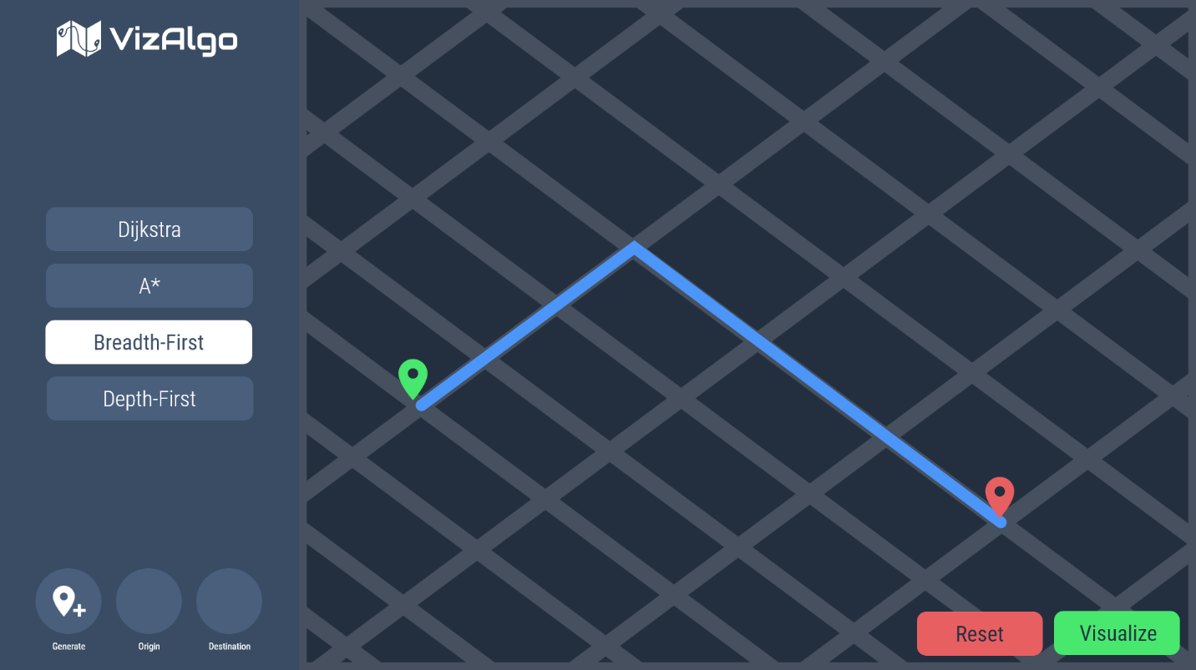

Table of Contents

Introduction 3

Purpose 3

Scope of Project 3

Glossary 3

Requirements Specification 4

Overview 4

Functional Requirements 4

Non-Functional Requirements 5

# Introduction

## Purpose

The purpose of this document is to describe an overview of the functionality of VizAlgo – Path Finder. This should give the reader an idea of what the user can do with this program.

## Scope of Project

VizAlgo – Path Finder, shall allow users to be able to visually see the process of different pathfinding algorithms in more realistic, dynamically generated maps.

## Glossary

|  |  |
| --- | --- |
| **Term** | **Definition** |
| User | The end-user of the system |
| Algorithm | A process a system goes through or a solution used to complete a problem |
| Pathfinding Algorithm | An algorithm which discovers a path from the origin to the destination, though not necessarily the shortest path |
| Origin | The starting location in the map |
| Destination | The ending location in the map |

# Requirements Specification

## Overview

Below, the specified requirements, such as functionality, for the software are listed.

## Functional Requirements

|  |  |
| --- | --- |
| **ID** | **Requirement** |
| F01 | The user shall generate a map |
| F02 | The user shall choose an algorithm |
| F03 | The user shall choose an origin |
| F04 | The user shall choose a destination |
| F05 | The user shall click “Visualize” button |
| F06 | The user shall click the “Reset” button |
| F07 | Upon a user choosing an algorithm, the system shall give options such as Dijkstra, A*, Breadth-First, and Depth-First |
| F08 | Upon a user choosing an origin, the system shall allow the user to drag and drop a pin onto the map |
| F09 | Upon a user choosing a destination, the system shall allow the user to drag and drop a pin onto the map |
| F10 | Upon a user clicking the “Visualize Algorithm” button, the system shall graphically visualize routes traversed by the algorithm through map-like animations |
| F11 | Upon a user clicking the “Reset” button, the system shall remove all path marks on the map and replace the origin and destination pins to its original location |
| F12 | Upon a user clicking the “Generate Map” button, the app shall be reset, and the map cleared, before generating the map |

## Non-Functional Requirements

|  |  |
| --- | --- |
| N01 | The system shall handle errors such that it recovers from them, at at-most 10 seconds |
| N02 | The system shall disable the “Visualize” button until both an origin, destination, and algorithm have been selected, and display a tooltip informing the user about how to enable the button. |
| N03 | The system shall display helpful tooltips upon hovering the cursor on the “Generate Map” button as well as the “Origin” and “Destination” pins |
| N04 | The system shall display tooltips on the algorithm selection to let the user know whether it uses weighted edges and whether it determines the shortest path |
| N05 | The system shall only allow one algorithm to be selected |
| N06 | Upon changes to window dimensions, the map section must be disabled and the user must be alerted that a new map must be generated |
| N07 | On mobile devices, disable the app and inform user that the app only works on desktop devices |